DIV information is stored in both GitHub and pepfar.net.

**GitHub**: <https://github.com/ICPI/DIV>

[DIV Wiki](https://github.com/ICPI/DIV/wiki): Contains resources and meeting notes

[DIV issues](https://github.com/ICPI/DIV/issues): Current and closed out projects and activities Organized by DIV subgroup: <https://github.com/ICPI/DIV/projects>

[DIV outcomes/products](https://github.com/ICPI/DIV): contains compilation of best practices, color palettes, ICPI logo, DIV presentations and trainings, and reference materials

**Pepfar.net**

[DIV Cluster folder](https://www.pepfar.net/OGAC-HQ/icpi/Shared%20Documents/Forms/AllItems.aspx?RootFolder=%2FOGAC%2DHQ%2Ficpi%2FShared%20Documents%2FClusters%2FDIV&FolderCTID=0x01200080CC6F83D1766F4D9E3497D4529EC74A&View=%7B94C838B2%2DE166%2D4122%2DB8B4%2D7BEB9E1BC12B%7D) on pepfar.net

* Administration 🡪 SOW, workplan
* 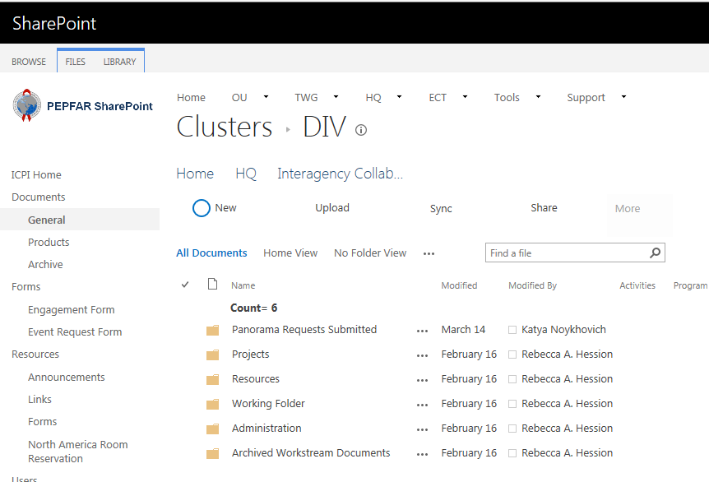Contains: Working Folder, Completed Projects, Panorama Requests, resources

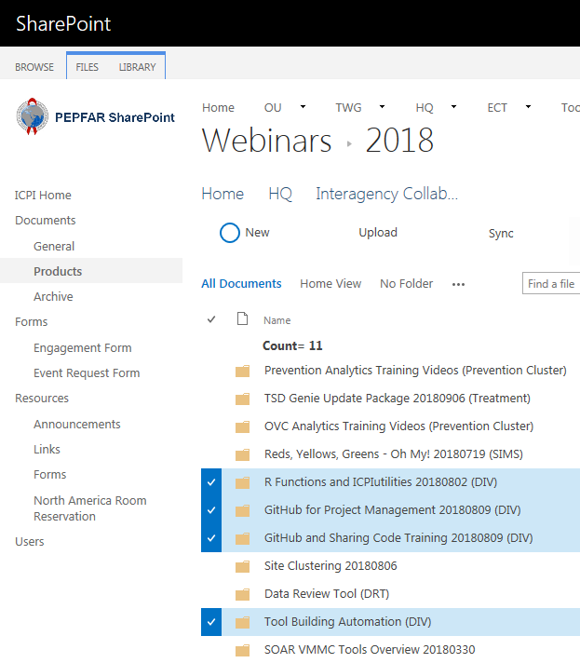[DIV Products on pepfar.net](https://www.pepfar.net/OGAC-HQ/icpi/Products/Forms/AllItems.aspx?RootFolder=%2FOGAC%2DHQ%2Ficpi%2FProducts%2FWebinars%2F2018&FolderCTID=0x012000C815322C717A7E4B8164EA374FA254EC00C3CC873FA325DD44884DEFC36053A859&View=%7B58E3102A%2DC027%2D4C66%2DA5C7%2D84FEBE208B3C%7D): Training webinars and brown-bags hosted